**Claim-Evidence-Reasoning Item Set ES – CER – River Erosion/Sediment Load**

Use the tables, charts, images and/or graphs below to write a Claim-Evidence-Reasoning (CER) that answers the following prompt: **“How does the angle of a slope effect the rate of erosion in a river system?”**

|  |  |  |  |  |  |
| --- | --- | --- | --- | --- | --- |
| **Elevation Drop per Kilometer** | | **Velocity of River** | | **Deposition of Sediment in River Bed (Bed Load) per Kilometer** | |
| **River One** | **51.2 m** | **River One** | **3.2 m/s** | **River One** | **98.8 Metric Tons** |
| **River Two** | **33.4 m** | **River Two** | **1.8 m/s** | **River Two** | **182.3 Metric Tons** |
| **River Three** | **16.7 m** | **River Three** | **0.9 m/s** | **River Three** | **234.4 Metric Tons** |
| **River Four** | **3.2 m** | **River Four** | **0.1 m/s** | **River Four** | **308.7 Metric Tons** |

**A diagram of a river and mountains
https://www.nps.gov/subjects/geology/fluvial-landforms.htm**

Image Source: https://www.nps.gov/subjects/geology/fluvial-landforms.htm

Upper Course

The river begins its descent through a narrow V-shaped valley. Falling steeply over a short distance, it follows a zig-zag course.

Middle Course

The river flows through a broad valley floored with sediments and changes its course quite frequently. It cuts into the bank on the outsides of the curves where the current flows fast and deep. Along the inside of the curves sand and gravel deposits build up.

Lower Course

The river meanders from side to side across a flat plain on which deep sediments lie, often the water level is higher than that of the plain. This is caused by the deposition of sediment forming high banks and levees. particularly at times of flood.

Sand and mud deposited at the river mouth form sand banks and may produce a delta.

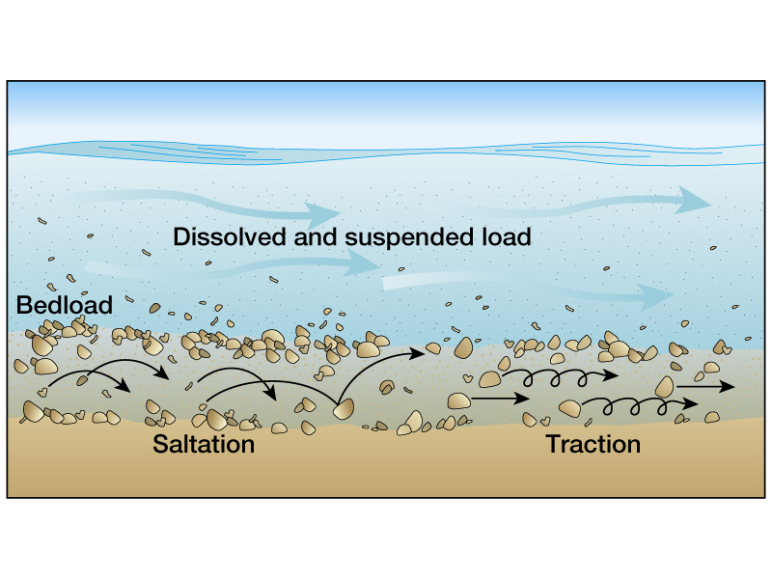

Image Source: ©2006 Pearson Prentice Hall, INC